**Analyzing the Meaning of words and Sentences:**

**The semantics of English sentences:**

Semantics is the study of meaning in human language. The theory of semantics mush seek to explain

Productivity 🡪 produce new or novel meaning

“The ugly man saw Mary and her cat that was next to a bat jump over the planet Venus”

This is a weird sentence, but we derived new meaning using productivity. The guiding principle we use to derive meaning is called **The principle of Compositionality.**

**Principle of Compositionality:** The meaning of a whole is a function of the meanings of the parts and of the way they are syntactically combined.

**Compositional Semantics in Feature-Based Grammar**

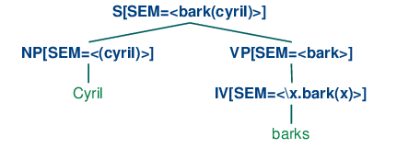

the sem value at the root node shows a semantic representation for the whole sentence, while the sem values at lower nodes show semantic representations for constituents of the sentence. Since the values of sem have to be treated in special manner, they are distinguished from other feature values by being enclosed in angle brackets.

suppose we have a NP and VP constituents with appropriate values for their sem nodes. Then the sem value of an S is handled by a rule like [(30)](https://www.nltk.org/book/ch10.html#ex-sem4). (Observe that in the case where the value of sem is a variable, we omit the angle brackets.)

|  |  |  |
| --- | --- | --- |
| (30) |  | S[SEM=<?vp(?np)>] -> NP[SEM=?np] VP[SEM=?vp] |

[(30)](https://www.nltk.org/book/ch10.html#ex-sem4) tells us that given some sem value ?np for the subject NP and some sem value ?vp for the VP, the sem value of the S parent is constructed by applying ?vp as a function expression to ?np. From this, we can conclude that ?vp has to denote a function which has the denotation of ?np in its domain. [(30)](https://www.nltk.org/book/ch10.html#ex-sem4) is a nice example of building semantics using the principle of compositionality.

To complete the grammar is very straightforward; all we require are the rules shown below.

VP[SEM=?v] -> IV[SEM=?v]

NP[SEM=<cyril>] -> 'Cyril'

IV[SEM=<\x.bark(x)>] -> 'barks'

The VP rule says that the parent's semantics is the same as the head child's semantics. The two lexical rules provide non-logical constants to serve as the semantic values of *Cyril* and *barks* respectively